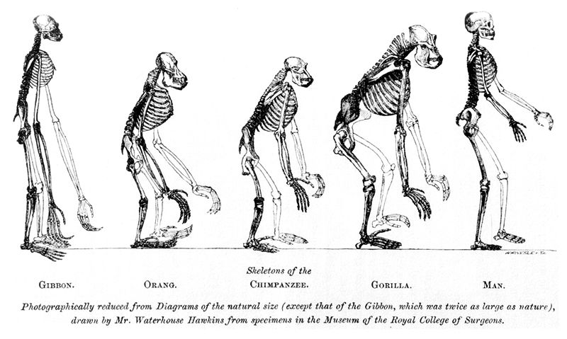
Evidence for Evolution Webquest
Overview:
You will explore the following pieces of evidence:

- Homologous Structures
Definition of “Homology”:

- Embryological Development
Definition:

- Biogeography
Definition:

- DNA & Molecular Biology

- Fossil Evidence

- Artificial Selection
Definition:

Begin at Berkeley’s “Understanding Evolution” site: http://evolution.berkeley.edu/evolibrary/article/0_0_0/lines_01
- List the 4 different lines of evidence:

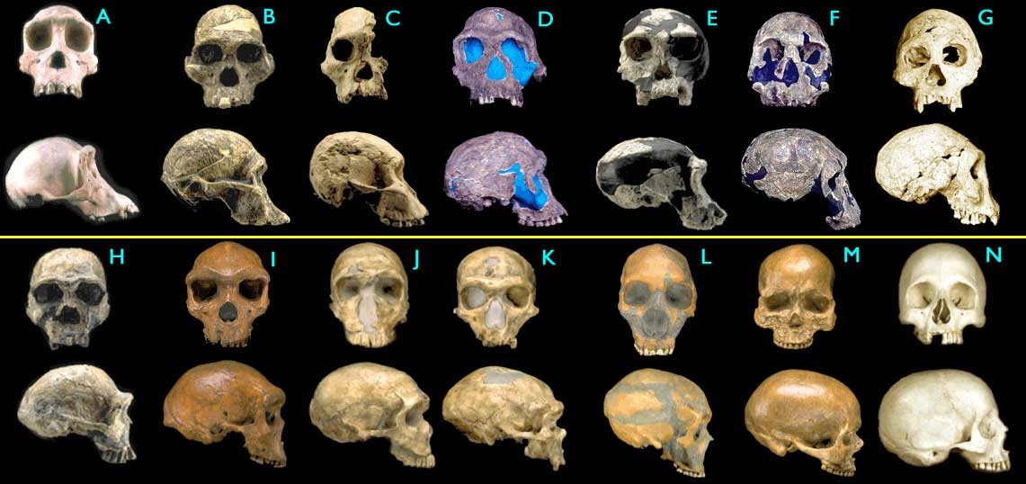
- Fossils:
- Click on “Fossil Evidence”.
- What clues do fossils provide?

- Click on “Next”.
- What are transitional forms?

- Describe 1 example:
- Homologies. Click on “Next”.
- What does evolutionary theory predict (hypothesize)?

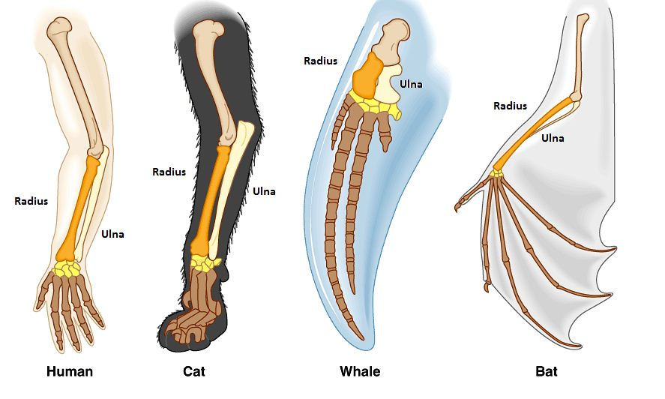
- How can homologies be revealed?

- Describe an example.

- Why are the forelimbs of frogs, rabbits, birds, and other tetrapods (4-limbed animals, including us!) considered homologous structures, even though they look so different?

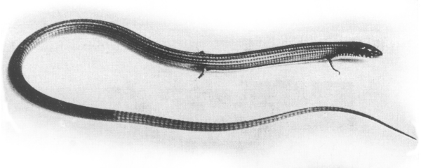
- Click on “Next”.
- What are vestigial organs?

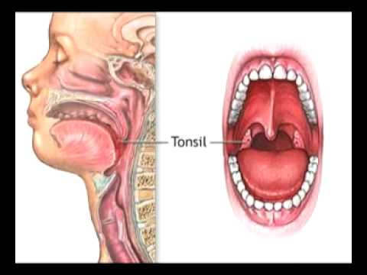
- Give an example.

- Click on “Next”.
- What is comparative anatomy?

- Give an example.

- Embryological Development. Click on “Next.”
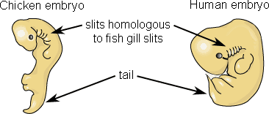
- What occurs during some stages of development?

- What is the evidence that supports the
hypothesis: snakes had ancestors with legs?

- What is the evidence that supports the hypothesis: baleen whales had ancestors with teeth?

- DNA Evidence. Click on “Next”.
- One componenet of the Cell Theory (which you learned last semester) is that all organisms are made of cells. How does this statement provide evidence for the theory of evolution: all living organisms share a common ancestor?


- What do different species share besides common anatomies?

- What shares ¼ of its genes with humans?

- How is the DNA code itself a homology?

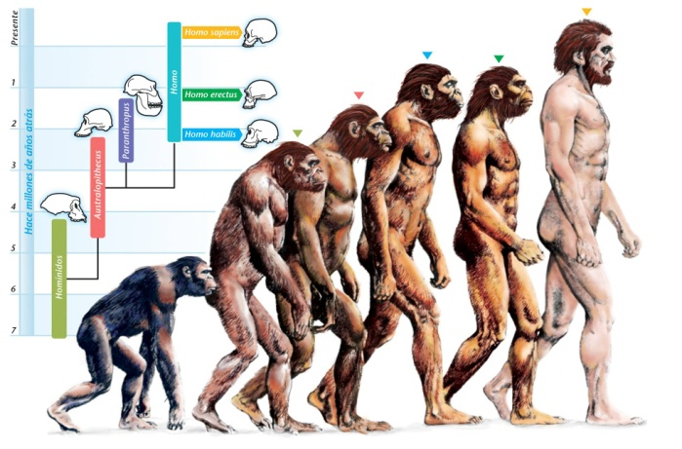
- Human Evolution—“How we Became Human”: Now, go to a fascinating website on how humans evolved from the Smithsonian:
- http://humanorigins.si.edu/evidence

- What are some pieces of evidence for human evolution? List 3.

Click on “Behavior”.
- Why do you think stone handaxes are evidence of early human behavior?

Click on one of the categories. Choose from: Art & Music, Making Clothing, Recording Information, Burial, Carrying & Storing, Hearths & Shelters, Stone Tools, Getting Food, Primate Behavior, & Footprints.
- What are 3 things you learned?

- How do these things relate to human evolution? What adaptations evolved?

Click on “Human Fossils”.
- What are some things we can learn from early human fossils? (List 3)

Click on “Species” (left hand side-bar).
Click on 2 different species.
- What were their names?

- How long ago did they live?

*(Extra Credit 3-5 pts): Draw a picture of 1 of them.

Click on “Genetics” (left side-bar).
Read the article.
- What does the amount of difference between DNA sequences in different species show?

- What is the amount of difference between yourself and every other human being on this planet?

- How different is our DNA from that of a chimpanzee’s?

Click on “Human Skin Color Variation” (left side bar).
Click on “Diversity—Skin Color”
- Why do people from different parts of the world have different skin color?

On the sidebar, under “Genetics”, click on “One Species, Living Worldwide”.
- What species do we all belong to?

- Where did the earliest humans evolve from?

Summary: What are 3 pieces of evidence that support the theory of evolution? Use at least 3 complete sentences. (1 extra credit point per extra sentence).

